SharedHome Milestone 2 Design and Prototype Report
Role adaptive smart home interaction for administrators older adults and children
Course Human Computer Interaction
Term Fall 2026
Milestone Solution Design and Prototype Development
Team Ramz Hamza Karam

This report documents the evidence chain, conceptual design, interactive prototype, and two formative design iterations completed for SharedHome.

Project Summary
SharedHome is a mobile smart home prototype that adapts interface complexity and access by household role. The design provides a simplified Elder view for Murium, a permission aware Child view for Ayun, and an Administrator view for device and access management. The prototype covers common household controls and adds Wi-Fi and the front door as hypothesis devices for testing safety and permission comprehension.
Two formative reviews support continuing with the role adaptive approach. Participants initially felt more comfortable but still needed time to adjust. After brief role specific guidance and terminology improvements were added, participants showed faster learning, adaptation, and completion. They responded positively to icons used with text labels, and one participant described the prototype as a "convenient experience." These are qualitative findings because numerical task times, errors, and participant level outcomes were not recorded.

Research Basis

Initial Participants
Participant | Role | Recorded finding | Evidence
Ramz | Technically comfortable administrator | Reported no difficulty using IoT controls | Direct interview
Murium | Older adult age 60 | Has difficulty navigating smart home controls | Direct interview
Ayun | Child age 10 | Requires limits on available controls | Direct interview

Evidence Boundaries
The three interviews establish differences in technical confidence and the need for child restrictions. They do not independently establish that users need restriction explanations, in-app access requests, temporary approvals, or progressive disclosure. Those interactions began as design hypotheses and were explored through the prototype. Wi-Fi and front-door controls are also hypothesis devices rather than devices reported in the initial interviews.
- The exploratory sample is small and drawn from one household context.
- Ramz is both a team member and participant, which may introduce response bias.
- The interview date, exact questions, and complete quotations are not recorded in the supplied research notes.
- The consent procedure for Ayun's direct participation should be documented in the study record.

Design Requirements
The requirements follow the course evidence chain from user problem to research finding, design requirement, HCI principle, design decision, and prototype feature. The evidence status column distinguishes interview findings from baseline usability requirements and hypotheses.
ID | Evidence status | Requirement | HCI rationale | Prototype response
DR1 | Interview supported | Present role appropriate interface complexity | Flexibility and cognitive load | Separate Administrator Elder and Child views
DR2 | Interview supported | Limit the Elder view to essential actions | Hick law and minimalist design | Large room scoped device controls
DR3 | Accessibility baseline | Make primary actions clear and easy to select | Visibility consistency and target size | Large labeled controls with visible state
DR4 | Interview supported | Restrict selected Child actions | Error prevention and safe exploration | Visible locked Wi-Fi AC and front-door controls
DR5 | Design hypothesis | Explain every unavailable action | System status and problem diagnosis | Plain language locked-control explanation
DR6 | Design hypothesis | Allow a restricted user to request access | User control and feedback | Request access action and status
DR7 | Design hypothesis | Let the administrator choose approval scope | Error prevention and reversibility | Once 1 hour Always and Deny options
DR8 | Usability baseline | Confirm each device or permission action | Visibility of system status | State changes request badges and feedback messages
DR9 | Iteration feedback | Support gradual learning and stable use | Consistency and recognition | Stable layout with dismissible Quick guides
DR10 | Iteration feedback | Pair device symbols with explicit labels | Recognition over recall | Icon name and state shown together

Conceptual Design

Personas

Murium
Murium is 60 years old and has low confidence with technology. She uses common household devices but finds smart home navigation difficult. Her interface emphasizes a few room-level controls, large targets, plain labels, and optional access to additional functions.

Ayun
Ayun is 10 years old and needs limits on available controls. His interface keeps allowed devices easy to reach and presents restricted controls as visible locked items. Wi-Fi and the front door are included as hypothesis devices for testing whether permission boundaries are understood.

Administrator
The administrator is comfortable with smart home controls and needs full device access, permission management, and efficient request handling. The interface prioritizes pending requests and shows the scope of each approval.

Scenarios and Task Flows
Scenario | Main flow | Success condition
Murium controls comfort | Open Elder view Select Fan Turn on Confirm state | Complete without help or entering settings
Ayun requests Wi-Fi | Open Child view Select locked Wi-Fi Read explanation Request access | Explain the restriction and send one request
Administrator resolves request | Open Administrator view Review request Select 1 hour Confirm | Grant only the intended device and duration

Information Architecture
- Prototype role switcher
- Administrator dashboard with requests devices and access settings
- Elder dashboard with Light Fan TV and progressive disclosure
- Child dashboard with allowed devices and visible locked controls
- Locked-control explanation request action and request status
- Approval choices for Once 1 hour Always and Deny

HCI Principles and Design Decisions
Principle | Design decision | Prototype implementation
Hick law | Reduce the number of visible choices in the Elder view | Three large primary controls with More controls hidden initially
Cognitive load reduction | Keep each role focused on its likely tasks | Role specific content and short contextual guidance
Recognition over recall | Show available devices and pair symbols with text | Icon device name and state appear together
Visibility of system status | Show the result of device and request actions | On and Off state badges pending requests and feedback messages
Error prevention | Stop restricted or high consequence actions before execution | Locked Child controls and scoped administrator approval
User control and freedom | Let users leave dialogs and reveal optional controls | Close and Escape actions plus dismissible guidance
Progressive disclosure | Delay secondary Elder controls until requested | Show more controls reveals temperature and help
Accessible target sizing | Provide generous touch areas and spacing | Large Elder tiles and clearly separated controls

Interactive Prototype
SharedHome is implemented as one clickable web prototype with a role switcher. State changes made in one role appear in the others, allowing a complete request and approval flow to be demonstrated in one session. The phone based format keeps the study to one platform while still allowing each role to receive a custom layout.

Device Scope
- Interview grounded devices include lights air conditioning television and fans.
- Wi-Fi and the front door are hypothesis devices used to test permission explanations safety boundaries and approval scope.
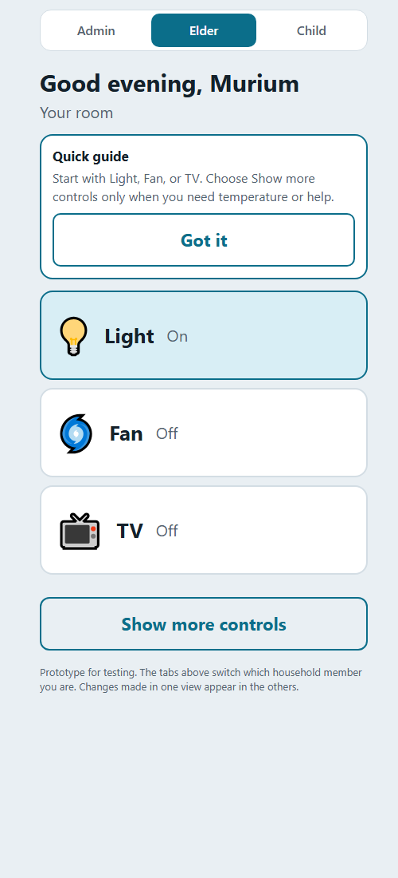  Elder view | 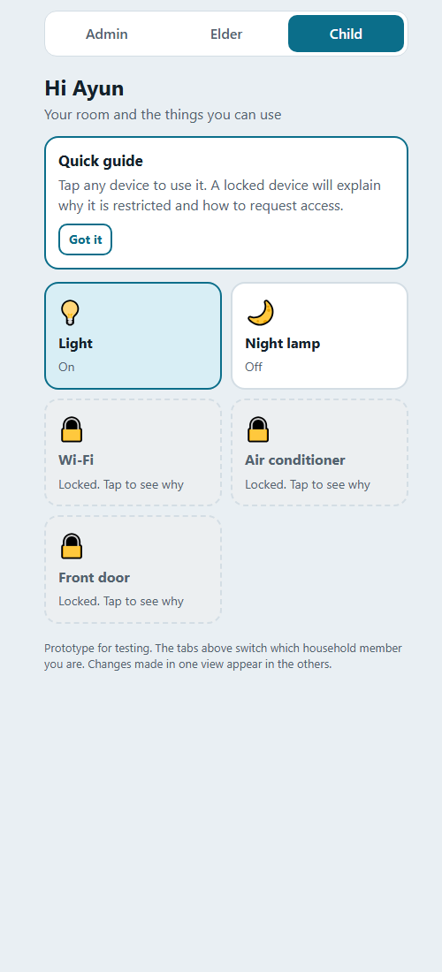  Child view
Figure 1 Role specific Elder and Child layouts

Administrator View
The Administrator view uses a denser management layout. Requests appear before device controls, and access settings expose the current permission state.
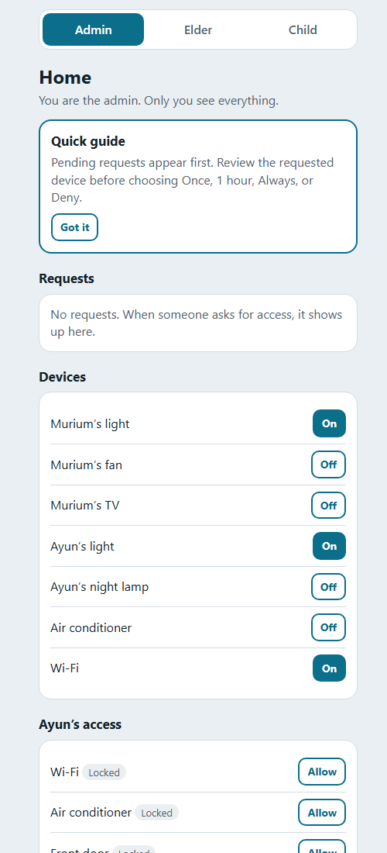
Figure 2 Administrator dashboard and access management

Iterative Refinement
Round | Observed feedback | Design response | Evidence limit
Iteration 1 | Participants felt more comfortable but still needed time to adapt | Keep role layouts and add learnability support | No task times errors or exact quotations recorded
Iteration 2 | Faster learning adaptation and completion positive response to icons "convenient experience" | Retain Quick guides stable placement icon plus label controls and consistent terminology | No numerical times participant-level results or quote attribution

Iteration 2 Changes
- Added short role specific Quick guides that users can dismiss.
- Preserved device placement so returning users can build familiarity.
- Replaced personal administrator names with consistent role terminology.
- Added dialog focus and Escape-key dismissal for locked controls.
- Kept icons as supporting cues alongside text labels and device state.

Interpretation
The second review suggests that contextual guidance and stable layouts improved perceived learnability and efficiency. Positive feedback on the device symbols supports the decision to pair icons with labels. The phrase "convenient experience" indicates favorable perceived usability but is not equivalent to a standardized usability score.
"Convenient experience"

Evaluation Readiness
The prototype supports task based evaluation in Phase 3. The next study should convert the current qualitative impressions into observable and measurable results.

Recommended Evaluation Tasks
1. Murium turns on her room fan without assistance.
2. Murium reveals More controls and adjusts the room temperature.
3. Ayun selects Wi-Fi explains why it is locked and sends a request.
4. The administrator identifies the request and grants access for one hour.
5. Ayun returns to Wi-Fi and identifies the updated access state.

Measures to Record
Measure | Recording approach
Task success | Completed completed with help not completed
Completion time | Seconds from task start to successful completion
Errors | Incorrect actions repeated actions or wrong permission scope
Assistance | Whether help was required and what prompt was given
Think aloud notes | Hesitations expectations and misunderstandings
Post task response | One exact comment about what felt clear or confusing
Standardized score | SUS or another course approved questionnaire in Phase 3

Team Responsibilities
Owner | Deliverables
Ramz | Design requirements and HCI principle justification
Hamza | Wireframes information architecture and interactive prototype
Karam | Personas scenarios user flows task models and iteration log

Conclusion
SharedHome translates the initial user differences into three role-adaptive layouts and a working cross-role permission flow. The Elder view reduces choice and enlarges controls, the Child view makes restrictions visible and actionable, and the Administrator view supports scoped decisions. The two formative iterations support retaining the custom layouts, contextual guidance, stable placement, and icon-plus-label presentation. Phase 3 should test the same flows with recorded task performance and standardized usability data.

References
Hick, W. E. (1952). On the rate of gain of information. Quarterly Journal of Experimental Psychology, 4(1), 11-26. https://doi.org/10.1080/17470215208416600
Nielsen, J. (1994). 10 usability heuristics for user interface design. Nielsen Norman Group. https://www.nngroup.com/articles/ten-usability-heuristics/
Norman, D. A. (2013). The design of everyday things: Revised and expanded edition. Basic Books.
World Wide Web Consortium. (2023). Web Content Accessibility Guidelines 2.2. https://www.w3.org/TR/WCAG22/

